**Angiographic Study of Normal Variations of Coronary Arteries In Normal Egyptian Persons**

E.M.Eid, N.A.Sarg, H.R.Mousa, and S.S.Abdelmonem

Anatomy and Embryology , Dept., Faculty of Medicine, Benha Univ., Benha, Egypt

E-Mail:shimaa@gmail.com

**Abstract**

the point was to contemplate the ordinary elements of the coronary corridors during life by utilizing quantitative coronary angiography concerning varieties and conceivably to help interventional cardiologist and heart specialist . The chose people (256) of both genders, 128 guys and 128 females, were separated into 4 subgroups as indicated by age ,Group A,(30Y:< 40Y), Group B,(40Y:< 50Y), Group C(50Y:< 60Y),Group D, their ages were over 60 years. The people enrolled for coronary angiography in catheterization lab unit in Benha University Hospital were taken a crack at this examination. Angiograms showing impediments were rejected from this investigation. The boundaries of the coronary corridors were bigger in guys than females with huge p-esteem for length of LMCA and distance across of RCA in regards to breadth of LMCA additionally was bigger among guys yet genuinely was nonsignificant. Trifurcation of LMCA discovered to be altogether more regular in guys than females .The mean measurement of the coronary supply routes commonly expanded with increment in age with critical p-esteem for width of LMCA in regards to the breadth of RCA additionally expanded with increment in age however measurably was nonsignificant. The boundaries of the coronary veins were bigger in guys than females. Trifurcation of LMCA discovered to be fundamentally more successive in guys than females. The mean distance across of the coronary conduits for the most part expanded with increment in age.

**Keywords:** Coronary angiography, coronary artery, coronary variation.

**1. Introduction**

Coronary course infection is perhaps the most well-known reasons for dreariness and mortality particularly in the industrialized nations, representing more than 33% of complete passings. Coronary corridor widths are quite possibly the main factors that influence the procedure and result of coronary by-pass operations [10].The word coronary methods enclosing in a way of crown. Blood vessel supply to heart is accomplished by two corridors which are the lone branches from rising aorta [6]. These veins branch in such a way that they involve atrioventricular and interventricular groove looking like a crown. Subsequently they are known as the coronary supply routes. Coronary corridors are the biggest vasa vasorum of the heart [9].The information on coronary conduit varieties and pathologies is significant in arranging the treatment and in understanding of discoveries of cardiovascular illnesses .the most ideal approach to stay away from injury to veins is to know all potential varieties in course, conveyance and branches. Any careful injury supported by veins is unsalvageable prompting the corruption of the part in question [4]. The investigation of typical elements of the coronary veins during life by utilizing quantitative coronary angiography can help interventional cardiologist and cardiovascular specialist [10].

**2. The aim of this work**

was to decide the variation stretching example of Left primary coronary vein and correlation between four age gatherings and among guys and females in regards to the length of Left principle coronary conduit , the breadth of Left fundamental coronary corridor and the measurement right coronary supply route.

**3. Subjects & Methods**

The chose people (256) of both genders, 128 guys and 128 females, were partitioned into 4 subgroups as per age, Group A, their ages went from 30 years up to under 40 years.It included 8 guys and 8 females. Gathering B, their ages went from 40 years up to under 50 years. It included 44 guys and 44 females, Group C, their ages ran from50 years up to under 60 years.It included 60 guys and 60 females, Group D, their ages were over 60 years. It included 16 guys and 16 females. The people enrolled for coronary angiography in catheterization lab unit in Benha University Hospital were taken on this investigation. The subjects were chosen from arrangements of people were shown for coronary angiography in the time frame from1/2018 till 1/2019. Angiograms showing impediments were prohibited from this investigation.

The greater part of the particular coronary angiographies were performed by the femoral strategy, albeit some were finished by the technique for brachial technique.

In coronary angiograms, left foremost diagonal view was utilized to gauge the correct coronary course (RCA) and right front sideways view was utilized to quantify the left coronary vein.

The correct front sideways view, The variation fanning example of LMCA was recorded as: Bifurcation of LMCA into two branches ( foremost interventricular vein (AIA) and circumflex course (CxA)) or trifurcation of LMCA as one other coronary conduit specifically ramus or middle of the road likewise takes root from LMCA.The length of LMCA was estimated from its place of starting to its place of division.The width of LMCA was estimated in the proximal piece of the separation from its starting to its division.

The left foremost slanted view, The breadth of RCA was estimated in the proximal piece of the distance between its start and intense negligible supply route.

**4. Results**

This examination included 256 patients, isolated into 4 age gatherings, The times of contemplated bunches went from 36 to 65 years with mean 51±7years. In the examined gatherings ,The mean length of the LMCA was 12.26 ±5.8 mm. In guys of examined gatherings ,The mean length of the LMCA was 14.02 ±6.29 mm while in females of contemplated gatherings ,The mean length of the LMCA was 11.27 ±5.28 mm. This distinction was altogether expanded in guys when contrasted and females of examined groups Table (1) , Fig (2) and Histogram (1).

The mean length of the LMCA old enough gathering (A)was 8.68 mm (range 8.27 - 24.21mm), while the mean length of the LMCA old enough gathering (B) was 9.2 mm (range 5.95 - 24.02mm) , This implies that the mean length of the LMCA unimportantly expanded from age gathering (A) to age gathering (B). The mean length of the LMCA old enough gathering (C)was 12.56 mm (range 4.51 - 24.01mm when contrasted and age gathering (B), this was genuinely critical, this worth demonstrates that the mean length of the LMCA expanded from age gathering (B) to age gathering (C). The mean length of the LMCA old enough gathering (D)was 8.06 mm (range 5.81 - 24.31mm) ,When contrasted and age gathering (C), There was a critical abatement in the mean length of the LMCA Table (2) , Fig (3-6) and Histogram (2).

In the contemplated gatherings, the mean measurement of the LMCA was 5.03 ±0.79mm. In guys of contemplated gatherings ,the mean distance across of the LMCA was 5.12 ±0.92mm .As respects females in the examined gatherings ,the mean breadth of the LMCA was 4.97 ±0.71mm. This distinction was measurably immaterial ,this implies that the breadth of the LMCA isn't influenced by sex(Table 1) , (Figs. 7 and 8) and (Histogram 1).. The mean width of the LMCA old enough gathering (A)was 4.52 ±0.33 mm, while the mean breadth of the LMCA old enough gathering (B) was 4.93 ±0.72mm, The mean distance across of the LMCA fundamentally expanded from age gathering (A) to age gathering (B). The mean breadth of the LMCA old enough gathering (C)was 5.12 ±0.81mm when contrasted and the mean width of the LMCA old enough gathering (B), This implies that the mean distance across of the LMCA unimportantly expanded from age gathering (B) to age gathering (C).The mean measurement of the LMCA old enough gathering (D) was 5.26 ±0.94 mm when contrasted and the mean measurement of the LMCA old enough gathering (C). This implies that the mean measurement of the LMCA inconsequential expanded from age gathering (C) to age gathering (D). The mean distance across of the LMCA by and large essentially expanded with increment in age Table (2), Fig (9-12) and Histogram (2).

In the examined gatherings, The mean distance across of the correct coronary corridor was 3.16 ±0.63mm. In guys it was 3.34 ±0.7mm, while in females the mean distances across of the correct coronary corridor was 3.06 ±0.57mm.This distinction was measurably huge, the mean measurement of the correct coronary conduit was altogether expanded in guys than in females of contemplated gatherings (Table 1) ,(Figs. 13 and 14) and (Histogram 1). In age gathering (A) the mean measurement of the correct coronary conduit of was 3.17 ±0.35 mm ,while it was 3.04 ±0.62 mm in age gathering (B),There was no altogether decline in the mean distance across of the correct coronary course from age gathering (A) to age gathering (B). The mean measurement of the correct coronary conduit old enough gathering (C)was 3.15 ±0.6 mm.it was 3.55 ±0.79mm in gathering (D). there was immaterial expansion in the mean distance across of the correct coronary supply route in gathering (C) when contrasted and the gathering (B) and in gathering (D) when contrasted and the gathering (C) .The mean width of the correct coronary corridor for the most part inconsequential expanded with increment in age Table (2) ,Fig (15-18) and Histogram (2).

In the contemplated gatherings, the level of bifurcation of LMCA was 219 (85.5%) While the level of trifurcation of LMCA was 37(14.5%) Fig (19 and 20) and Histogram (3).

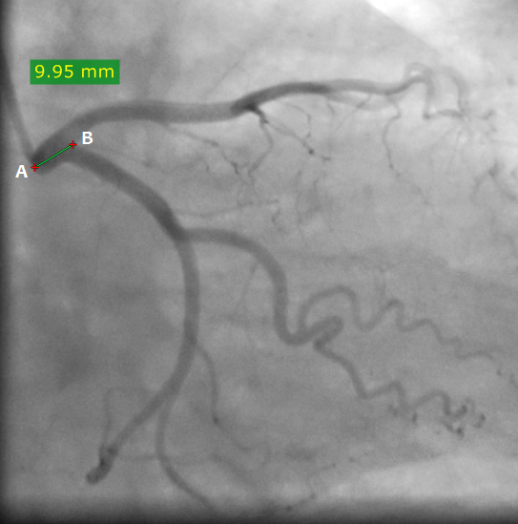

**Fig(1)** A photograph of coronary angiogram of a male from group A aged 38years showing the length of left main coronary artery (AB) 9.95 mm.

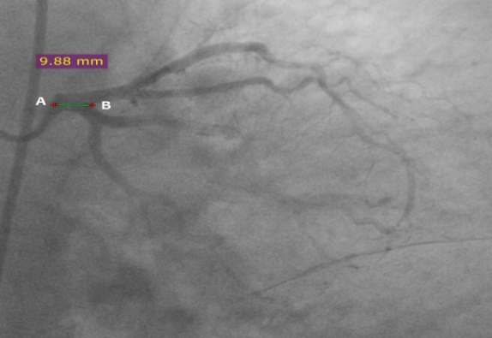

**Fig (2)** A photograph of coronary angiogram of a female from group B aged 48years showing the length of left main coronary artery (AB) 9.88mm.

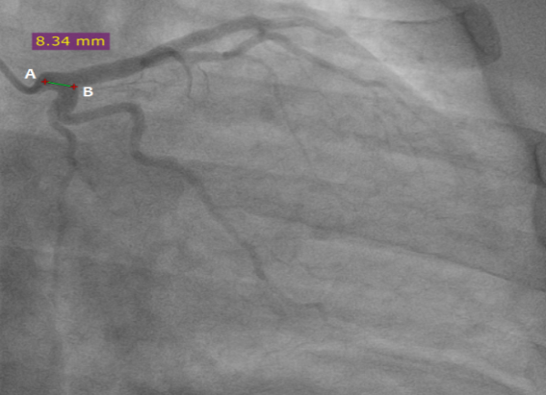

**Fig (3)** A photograph of coronary angiogram of a female from group A aged 37years showing the length of left main coronary artery (AB) 8.34 mm.

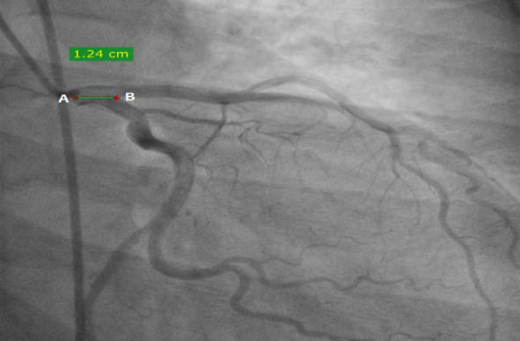

**Fig (4)** A photograph of coronary angiogram of a male from group B aged 44years showing the length of left main coronary artery (AB) 12.4 mm.

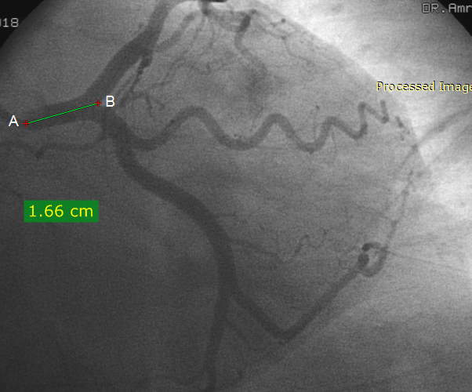

**Fig (5)** A photograph of coronary angiogram of a male from group C aged 56years showing the length of left main coronary artery (AB) 16.6mm.

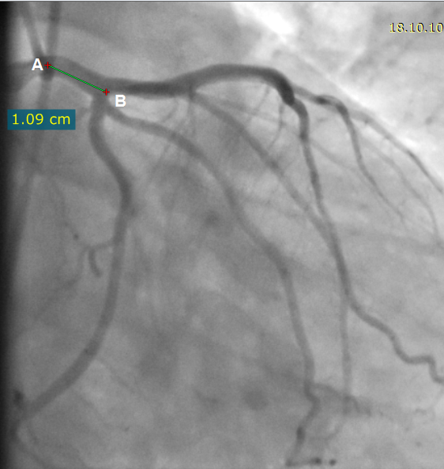

**Fig (6)** A photograph of coronary angiogram of a female from group D aged 61years showing the length of left main coronary artery (AB) 1.09 cm.

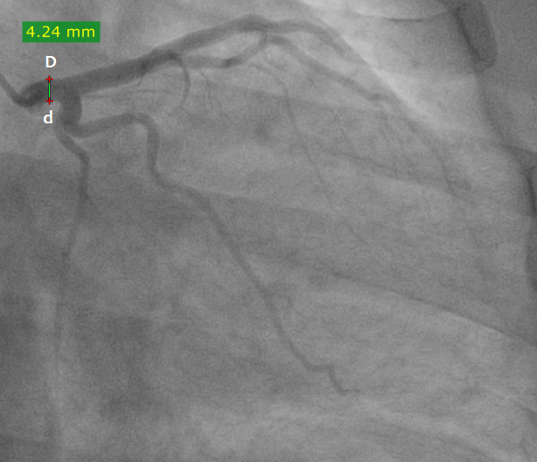

**Fig (7)** A photograph of coronary angiogram of a male from group A aged 38 years showing the diameter of left main coronary artery (Dd) 4.24mm.

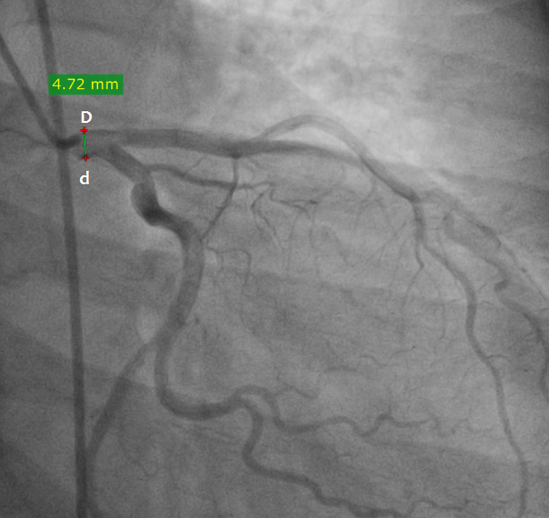

**Fig (8)** A photograph of coronary angiogram of a female from group B aged 48 years showing the diameter of left main coronary artery (Dd) 4.72 mm.

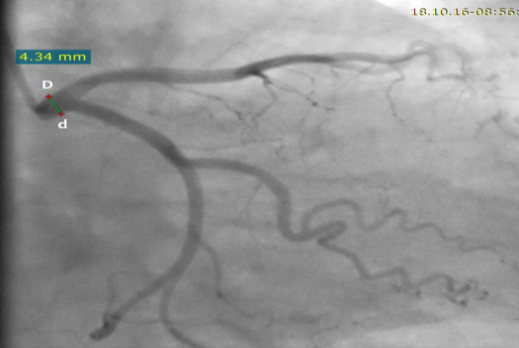

**Fig.(9):** A photograph of coronary angiogram of a female from group A aged 37 years showing the diameter of left main coronary artery (Dd) 4.34 mm.

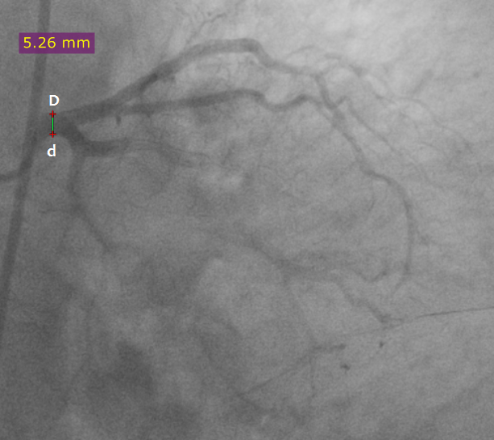

**Fig (10)** A photograph of coronary angiogram of a male from group B aged 44 years showing the diameter of left main coronary artery (Dd) 5.26 mm.

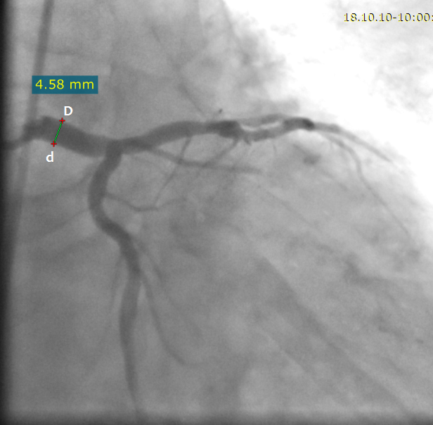

**Fig (11)** A photograph of coronary angiogram of a female from group C aged 57 years showing the diameter of left main coronary artery (Dd) 4.58 mm.

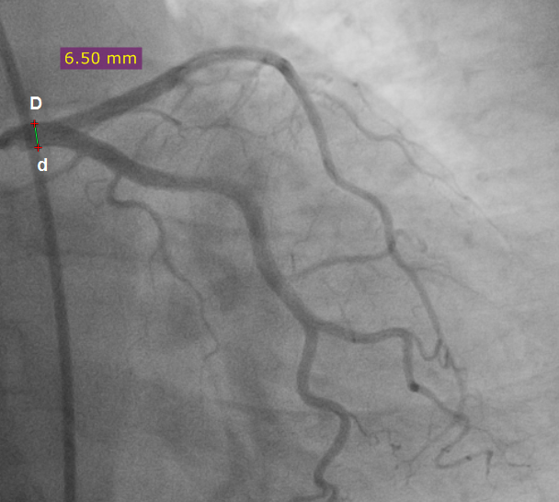

**Fig (12)** A photograph of coronary angiogram of a male froum group D aged 63 years showing the diameter of left main coronary artery (Dd) 6.50 mm.

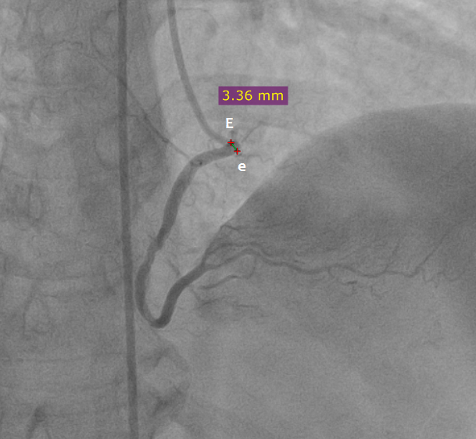

**Fig (13)** A photograph of coronary angiogram of a male from group A aged 38 years showing the diameter of right coronary artery (Ee) 3.36 mm.

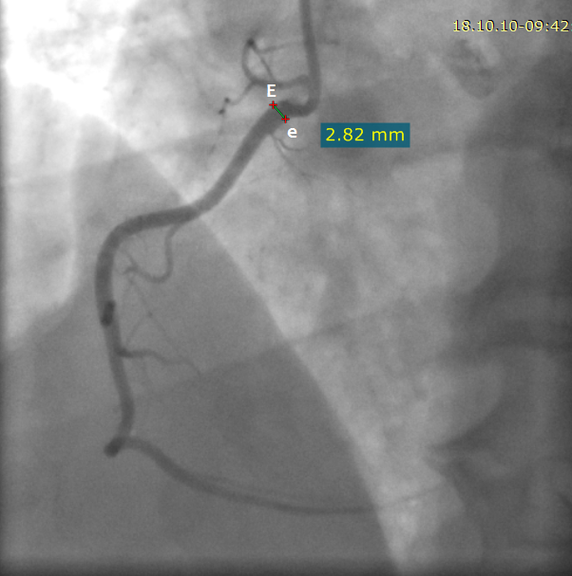

**Fig (14)** A photograph of coronary angiogram of a female from group B aged 48 years showing the diameter of right coronary artery (Ee) 2.82 mm.

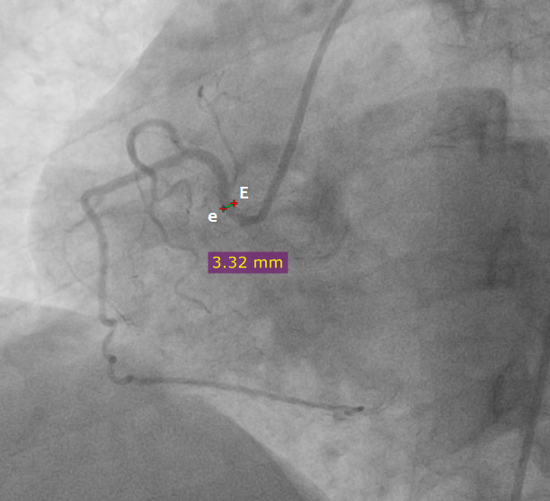

**Fig (15)** A photograph of coronary angiogram of a female from group A aged 37 years showing the diameter of right coronary artery (Ee) 3.32mm.

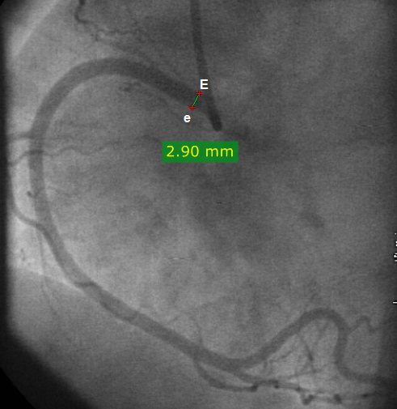

**Fig (16)** A photograph of coronary angiogram of a male from group B aged 44 years showing the diameter of right coronary artery (Ee) 2.90mm.

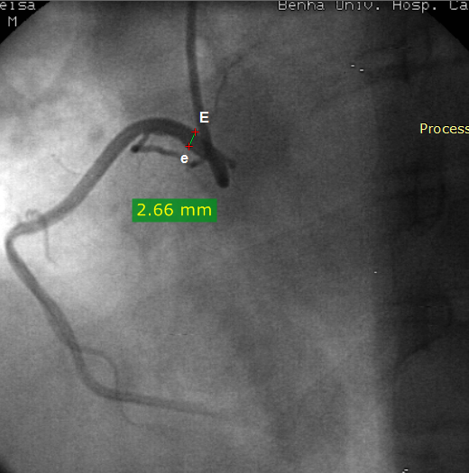

**Fig (17)** A photograph of coronary angiogram of a female from group C aged 57 years showing the diameter of right coronary artery (Ee) 2.66mm.

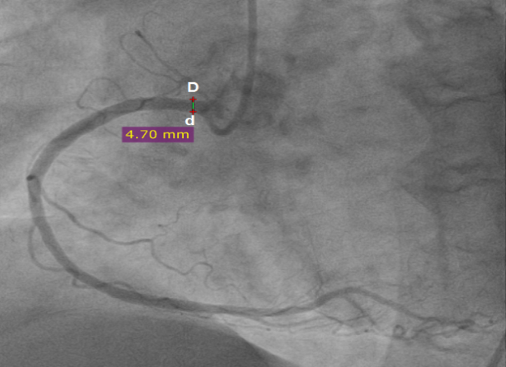

**Fig (18)** A photograph of coronary angiogram of a male from group D aged 63years showing the diameter of right coronary artery (Ee) 4.70 mm.

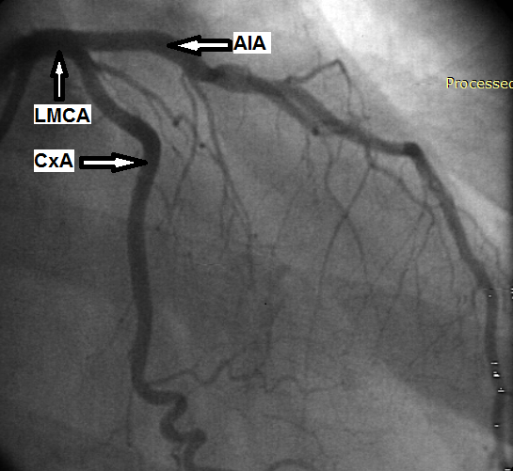

**Fig (19)** A photograph of coronary angiogram of a female from aged 61 years showing the bifurcation of the left main coronary artery into anterior interventricular artery (AIA) and circumflex artery(CxA).

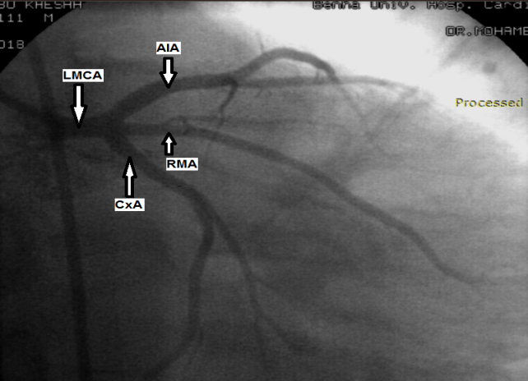

**Fig (20)** A photograph of coronary angiogram of a male from aged 57 years showing the trifurcation of the left main coronary artery into anterior interventricular artery (AIA), circumflex artery (CxA) and ramus medianus artery (RMA).

**Table (1)** showing variations of parameters of coronary arteries according to gender.

|  |  |  |  |  |
| --- | --- | --- | --- | --- |
|  |  | **Males (n = 128)** | **Females (n = 128)** | **P value** |
| **Length of LMCA (mm)** | **Mean ±SD** | 14.02 ±6.29 | 11.27 ±5.28 | 0.002 Highly significant  ( group A vs group B) |
| **Diameter of LMCA (mm)** | **Mean ±SD** | 5.12 ±0.92 | 4.97 ±0.71 | 0.252 Non significant |
| **Diameter of RCA (mm)** | **Mean ±SD** | 3.34 ±0.7 | 3.06 ±0.57 | 0.002 significant |

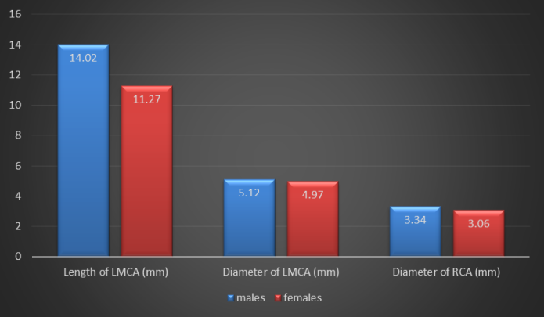

**Histogram (1)** showing variations of parameters of coronary arteries according to gender

|  |  |  |  |  |  |  |
| --- | --- | --- | --- | --- | --- | --- |
|  |  | **Group A**  **(n = 16)** | **Group B**  **(n = 88)** | **Group C**  **(n = 120)** | **Group D**  **(n = 32)** | **P value** |
| **Length (mm)** | **Mean** | 8.68 | 9.22 | 12.56 | 8.06 | 0.008Highly significant |
| **Range** | 8.27 - 24.21 | 5.95 - 24.02 | 4.51 - 24.01 | 5.81 - 24.31 |
| **Diameter of LMCA (mm)** | **Mean ±SD** | 4.52 ±0.33 | 4.93 ±0.72 | 5.12 ±0.81 | 5.26 ±0.94 | 0.002 significant |
| **Diameter of RCA (mm)** | **Mean ±SD** | 3.17 ±0.35 | 3.04 ±0.62 | 3.15 ±0.6 | 3.55 ±0.79 | 0.121Non significant |

**Table (2)**:showing variations of parameters of coronary arteries according to age groups

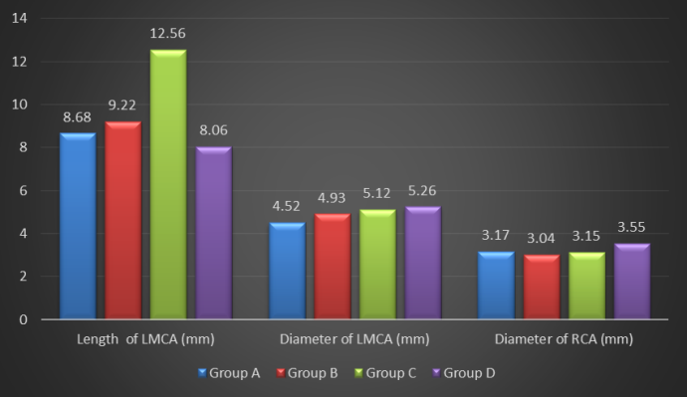

**Histogram (2)** showing variations of parameters of coronary arteries according to age groups.

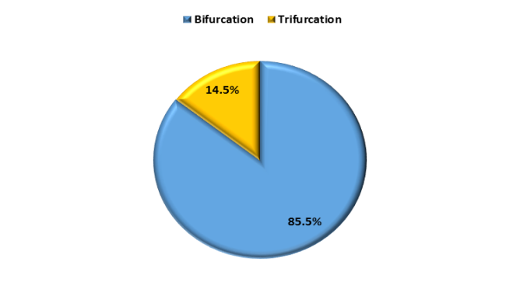

**Histogram (3)** Branching patterns of left main coronary in the studied groups**.**

**5. Discussion**

In this examination the mean length of LMCA was 12.26 ±5.8 mm in the contemplated gatherings. the mean length of LMCA was essentially expanded in guys when contrasted and females of contemplated gatherings. The mean length of the LMCA by and large essentially expanded from age gathering (A) to age gathering (C). This outcome was in accordance with that of (5) ,found in an examination among Indian populace the mean length of LMCA was 9.05 ± 3.61 mm . (1) ,performed comparable examination among South African populace and tracked down that the mean length of LMCA was 10.4± 4.1 mm and there were no measurably critical contrast among guys and females .

In the current investigation the mean breadth of LMCA was 5.03 ±0.79 mm in the considered gatherings, The mean width of LMCA inconsequential expanded in guys when contrasted and females. The mean measurement of the LMCA by and large essentially expanded with increment in age. The component by which maturing influences the coronary

supply route measurement can't be decisively clarified, it very well may be clarified by growing of the course to adjust with thickening of the blood vessel divider with aging(10). This outcomes were like the consequence of the investigation done by (8) which showed slight inclination for grown-up coronary size to increment with age .These outcomes were in concurrence with that of (10) , whose review among Turkish populace ,They estimated the measurement of LMCA in 77coronary angiograms ,the scope of the age was somewhere in the range of 31 and 79 years ,They tracked down that the mean breadth of LMCA was 4.43±0.76 mm in . The mean width of LMCA was irrelevantly expanded in guys when contrasted with females in a similar report. The contrast between the mean estimations of the measurements of LMCA as per the age were discovered measurably immaterial in the considered gatherings..

The mean breadth of the correct coronary corridor was 3.16 ±0.63mm.mm in the examined gatherings, It was fundamentally expanded in guys than in females .Larger widths saw in guys show that sexual orientation is a factor that influences coronary supply route distance across. Hormonal components are most likely liable for this distinction. Since coronary conduit sicknesses are more successive in guys than females, other illness hazard factors instead of the measurements are involved(10). The mean distance across of the correct coronary vein commonly irrelevantly expanded with increment in age .This outcome was almost like that of (10) , whose review among Turkish populace ,estimated the breadth of the correct coronary corridor in 77coronary angiograms ,the scope of the age was somewhere in the range of 31 and 79 years ,tracked down that the mean measurement of the correct coronary conduit was 3.45±0.5 mm in the considered gatherings, the mean width of the correct coronary course was inconsequential expanded in guys when contrasted with females in there study . The contrast between the mean estimations of the distances across of the correct coronary conduit as indicated by the age were found genuinely unimportant between the considered age gatherings. In the current examination, the level of bifurcation of LMCA was 219 (85.5%) and the level of trifurcation of LMCA was 37(14.5%) in the considered gatherings, trifurcation of LMCA was seen as one other coronary corridor to be specific middle supply route additionally takes root from LMCA .trifurcation discovered to be altogether more continuous in guys than females .This outcome was in accordance with that of (4), (2) who concentrated among Turkish populace, the stretching design was noted in 5,548 coronary angiograms, the scope old enough was 61.3 ± 11.3 years. Occurrence of trifurcation was discovered to be altogether more continuous in guys than females .

**6. Conclusion**

Overall guys have bigger coronary vein boundaries than females .Trifurcation discovered to be essentially more continuous in guys than females. The mean breadth of the coronary veins commonly expanded with age.

**References**

1. ‏ N.O.Ajayi, L.Lazarus, E.A.Vanker, K.S.Satyapal. Anatomic Parameters of the Left Coronary Artery: an Angiographic Study in a South African Population. International Journal of Morphology.vol.31(4),pp,2013.
2. ‏C.Altin, S.Kanyilmaz, S.Koc, Y.C.Gursoy, U.Bal, A.Aydinalp, H.Muderrisoglu.:Coronary anatomy, anatomic variations and anomalies: a retrospective coronary angiography study. Singapore medical journal.vol.56(6),pp. 339,2015.
3. A.Dhakal, S.Pandey, A.Maskey, S.Yadav. Does populational difference influence the size of adult human coronary arteries?. Journal ofExperimental and Clinical Anatomy.vol.16(1),pp. 36,2017.
4. Y.Diwan, D.Diwan, R.S.Chauhan, P.C.Negi. Coronary artery anomalies in North Indian population: a conventional coronary angiographic study. National Journal of Clinical Anatomy.vol.6(4),pp. 250,2017.
5. V.H.Nguyen, E.F.Talarico Jr. A morphometric anatomical study on the division of the left main coronary artery and myocardial bridges. Eur. J. Anat.vol. 22(4),pp. 355-365,2018.
6. ‏ B.Pusala, M.V.Reddy. Termination and dominance of coronary arteries: on Telangana population. Int J Anat Res.vol. 5(2.1),pp.3735-40,2017.
7. I.G.Shukri, J.M Hawas, S.H.Karim, I.K.M.Ali. Angiographic study of the normal coronary artery in patients attending ulaimani center for heart diseases. European Scientific Journal.vol.10,pp.(24) ,2014.
8. S.Standring, N.Anand, G.Jawaheer, R.S.Tubbs Gray’s anatomy, Forty-first edition. Elsevier, Ch.vol.7,pp.1019,1020,2015.
9. O.Turamanlar, F.Adali, M.B.Acay, E.Horata, O.Tor, O.Macar, Y.Abbasoğlu, Angiographic analysis of normal coronary artery lumen diameter in a Turkish population. Anatomy.vol.10,pp.(2), 2016.
10. ‏ C.Saikrishna, S.Talwar, G.Gulati, A. S. Kumar. Normal coronary artery dimensions in Indians. Indian Journal of Thoracic and Cardiovascular Surgery. Vol. 22(3), pp. 159-164, 2006.